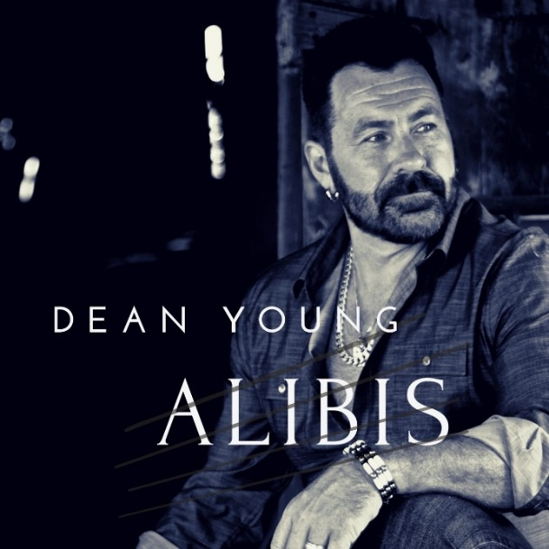
Photo – Mark Maryanovich Photography
ALIBIS - In Memory of Adam T. Wallington
A co-write with a dear friend of mine, Adam Wallington.
We initially wrote it in 1998 and re-visited it in 2014.
We had always planned to work on it more in order to bring it a more "country" feel but unfortunately, in 2020 Adam was diagnosed with ALS.
He passed away January 24th 2021 at the age of 46.
You'll see “Meow” referenced by friends of Adam and the meaning of it is...Adam loved cats and has had many over the years. He would both greet and part ways with friends with a "Meow". He had this incredible pretend voice that he would talk to his pets with and his world revolved around them.
Adam was a fantastic writing partner, a bandmate (New York Minute) and an incredible support in working on/producing my demos for Makin' A Life and the launch of that album.
He produced the contest video for Last Man Standing and we shared the stage again at Hugh's room (Toronto) in early 2016 where we performed it live for judges.
Adam had this incredible deep, smooth and very soulful singing voice that was one of a kind.
I can honestly say, I'm still in shock that he's gone.
I am releasing the song, mastered as is, in memory of an immense talent and dear friend; the world lost a good one and he'll be greatly missed.
Till we meet again my friend.
"Meow" R.I.P.
The song goes "live" on all music services February 24th and I hope you keep your eyes & ears on the watch for it. Please "like, love, follow and share" it and I hope to honour this great person with a listen from the world.

DEAN YOUNG
CANADIAN SINGER | SONGWRITER | MUSICIAN
Niagara Ontario musician Dean Young’s original country music is described as a twist of modern with classic country sounds that carries meaningful messages to listeners about the important things in life. Although Dean's songwriting spans many genres, it's country that continually draws his heart as that was the musical foundation of his youth.

A self-taught musician who was singing at square dances by age 3, he was first introduced to the guitar at a young age by his father Bazil, and started playing drums at age 15. He quickly caught the attention of the local music circuit and was soon playing drums while singing lead and backing with numerous bands in ON such as New York Minute, 21 Plus, White Frost, The Limit, Hotel California, Epic Eagles etc.
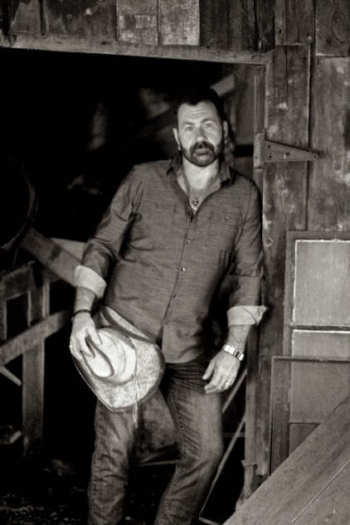
Grateful to be able to share his passion and uplift the people who love and appreciate music he’s had the opportunity to tour and perform for audiences from 200 - 60,000 across North America, Japan & Mexico.

Albums D’n’R Unplugged (‘09), Young Country (‘11), Makin’ A Life (’17 – Barrytone Studios), Dirty (Single 2018), and Alibis (Single 2021) Dean's music is heard on stations across North America.
REVIEWS: https://deanyoungmusic.com/reviews-press-kit
ALIBIS UPC: 195999573472
SOCIALS:
Facebook
Instagram
Twitter
YouTube

